Determining the density of CO₂ Riley Rifkin
Methods and Materials:
Begin the experiment by collecting these materials: 1 Alka-Seltzer tablet, 1 rubber tubing, 1 50 ml graduated cylinder, 1 test tube, 2 rubber stoppers, 250 ml Erlenmeyer flask, 1000 ml beaker, and 1 scale. Once materials are collected, ensure eye protection by wearing safety goggles. Start by splitting Alka-Seltzer tablet in half and setting aside in a safe place. Then connect rubber tubing to rubber stopper. Fill 250 ml Erlenmeyer flask with about 50 ml of water. Put 700 ml of water into 1000 ml beaker. Use scale to weigh test tube with rubber stopper in place to get an accurate mass of test tube with air trapped inside. Continue to use the scale and weigh test tube with water filled to the top with rubber stopper in place to get an accurate mass of test tube with water. Next use 50 ml graduated cylinder to carefully pour into the test tube. Once test tube is completely filled, subtract the amount of water left in the graduated cylinder from the initial 50 ml. Approximately 21.5 ml should be in test tube. Place the filled test tube upside down in the 1000 ml beaker using speed to prevent any air from immersing itself in the test tube. Use fingers to insert rubber tubing underwater into the test tube. Put ½ of Alka-Seltzer tablet into 50 ml of water in the 250 ml Erlenmeyer flask and put rubber stopper with rubber tube attached in place. Water will be displaced from the test tube and CO₂ will fill inside (Figure 1). Put a rubber stopper in bottom of test tube once all water is out. Weigh test tube with CO₂. The mass of the CO₂ can then be determined by taking the mass of test tube with CO₂ and subtracting the mass of test tube when previously filled with only air (Table 1). This is the mass of the CO₂ created. Volume can be found by how much water the test tube was filled with before it displaced the liquid and filled with gas. Divide mass by volume to find density and record results (Table 2) along with the percent error (Table 3).
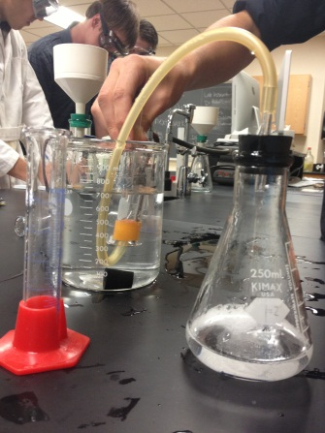
Figure 1: Test tube is upside down in 1000 ml beaker while Alka-Seltzer tablet reacts and creates CO₂ being pushed through rubber tubing into test tube displacing H₂O.
Results:
Table 1: Calculating Mass
Test tube mass w/ air (g) | Test tube mass with water (g) | Test tube mass with CO₂ (g)
23.151 g | 44.757 g | 23.196 g
To calculate mass of CO₂ subtract the test tube mass with air from the test tube mass with CO₂.
Sample: (23.196 g - 23.151 g) mass = 0.045 g
Table 2: Calculating Density
Mass (g) | Volume (ml) | Density (g/ml)
0.045 g | 21.5 ml | 0.00209 g/ml
To calculate density use the equation d = m / v.
Sample: (d = 0.045 g / 21.5 ml) d = 00.209 g/ml

Table 3: Percent Error
Known density of CO₂ (g/l) | Discovered density of CO₂ (g/l) | Percent Error (%)
1.965 g/l | 2.09 g/l | 6.361%
To calculate percent error use the equation lApproximate Value - Exact Valuel / lExact Valuel x100.
Sample: (l2.09 g/l -1.965 g/ll / l1.965 g/ll x100) Percent Error = 6.361%

The mass was calculated by subtracting the test tube without CO₂ from the test tube filled with CO_{2.} Because the gas (CO₂ ) was contained in a test tube with no markings, a graduated cylinder with milliliters was used to fill the test tube to its determined volume of 21.5 ml. Only having one trial of this experiment limits the capability to view variability and different trends in the data.

